**Real-Time Messaging Platform**

**1. Introduction**

The purpose of this report is to present an overview of a real-time messaging platform that utilizes distributed systems to provide efficient and scalable messaging capabilities. Real-time messaging platforms are widely used in various applications, including chat applications, collaboration tools, and social media platforms. By leveraging distributed systems, these platforms can handle high traffic loads, ensure fault tolerance, and deliver messages in near real-time.

**2. Architecture Overview**

The real-time messaging platform consists of the following key components:

**2.1. Client Applications:** The platform supports various client applications, such as mobile apps, web browsers, and desktop clients. These applications interact with the messaging platform to send and receive messages.

**2.2. Messaging API**: The Messaging API acts as the interface between the client applications and the messaging platform. It provides methods for sending and receiving messages, as well as managing user authentication and authorization.

**2.3. Distributed Message Broker:** The distributed message broker is responsible for receiving, storing, and distributing messages across multiple nodes in the distributed system. It ensures reliable message delivery and high availability. Examples of distributed message brokers include Apache Kafka, RabbitMQ, and Apache Pulsar.

**2.4. Message Storage:** Messages are stored in a distributed storage system, such as Apache Cassandra or Apache HBase, to provide scalability and fault tolerance. The distributed storage system ensures that messages are replicated across multiple nodes to prevent data loss.

**2.5. User Presence Service:** The user presence service keeps track of the online/offline status of users. It allows clients to determine the availability of other users and provides features like typing indicators and read receipts.

**2.6. Load Balancer:** The load balancer distributes incoming client requests across multiple instances of the messaging platform to ensure optimal resource utilization and scalability.

**3. Key Features**

The real-time messaging platform offers the following key features:

**3.1. Instant Message Delivery:** The distributed nature of the platform allows for near real-time message delivery, ensuring that messages are transmitted to recipients quickly and reliably.

**3.2. Scalability:** The platform can handle a large number of concurrent users and messages by distributing the workload across multiple nodes. As the user base grows, additional nodes can be added to the system to handle the increased load.

**3.3. Fault Tolerance:** The distributed systems architecture provides fault tolerance by replicating messages and data across multiple nodes. In the event of a node failure, the system can continue operating without data loss.

**3.4. Presence and Notifications:** The user presence service enables users to see the online status of their contacts and receive notifications when new messages arrive. It also supports additional features like typing indicators and read receipts.

**3.5. Cross-Platform Support:** The platform is designed to support various client applications, allowing users to seamlessly switch between devices while maintaining their conversations and message history.

**4. System Deployment and Scalability**

To deploy the real-time messaging platform, the following steps can be followed:

4.1. Set up a cluster of distributed message brokers, such as Apache Kafka, to handle message distribution and ensure fault tolerance.

4.2. Configure a distributed storage system, such as Apache Cassandra or Apache HBase, to store messages and ensure scalability.

4.3. Deploy multiple instances of the messaging platform, load balanced by a load balancer, to handle incoming client requests and distribute the workload.

4.4. Set up a user presence service to track user availability and enable additional features like typing indicators and read receipts.

4.5. Integrate client applications with the messaging API to send and receive messages, manage user authentication, and handle notifications.

4.6. Monitor the system's performance and scalability metrics to ensure optimal resource utilization and handle increased traffic by adding more nodes to the distributed system as necessary.

**5. Code and Output:**

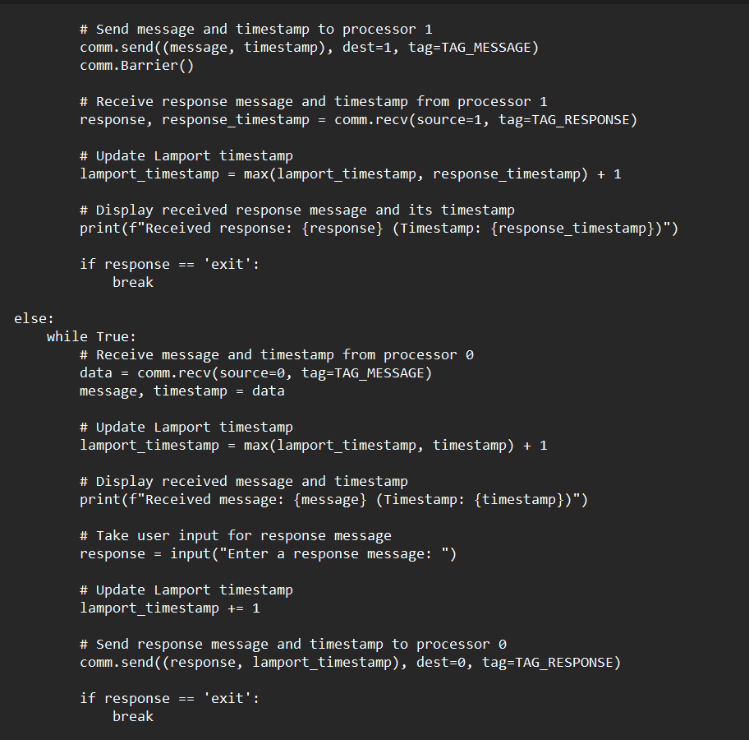

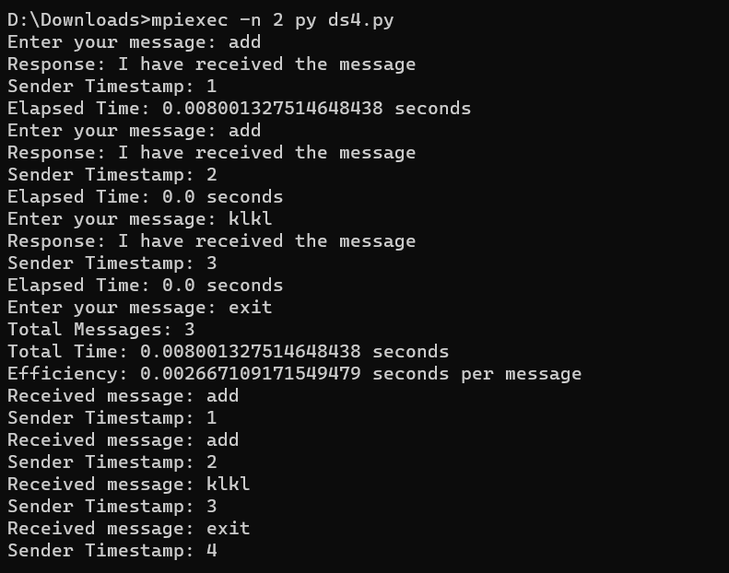

**6. Conclusion:**

The real-time messaging platform, powered by distributed systems, provides a scalable, fault-tolerant, and efficient solution for handling messaging requirements in various applications. By leveraging distributed message brokers, distributed storage systems, and load balancing techniques, the platform can handle high traffic loads, ensure fault tolerance, and deliver messages in near real-time. With features such as user presence and cross-platform support, the platform offers a seamless messaging experience for users across different devices.